Experiment No.10
Title: Wi-Fi Network Scanning using Mobile Apps (SSID, RSSI, Channel Mapping)

Aim: To scan and analyze nearby Wi-Fi networks by measuring parameters such as SSID, RSSI, channel number, and frequency using the WiFi Analyzer (open-source) application on a smartphone. Requirement:

Hardware
• Android smartphone with Wi-Fi capability and Wi-Fi router or access point
Software
• WiFi Analyzer (open-source) by VREM Software Development

Theory :
Wi-Fi (IEEE 802.11) is the most widely used wireless networking technology for providing internet and data connectivity. Wi-Fi networks operate in the unlicensed 2.4 GHz and 5 GHz frequency bands. Multiple Wi-Fi networks often coexist in the same environment, especially in residential areas, offices, and public spaces. These networks may interfere with each other, affecting performance and user experience. Wi-Fi network scanning is a fundamental technique used to discover and analyze available wireless networks. It helps in understanding the wireless environment, identifying sources of interference, and optimizing network performance. Tools like WiFi Analyzer (open-source) by VREM Software Development provide a simple and effective way to perform such analysis using a smartphone.
Fundamental Concepts a) SSID (Service Set Identifier): The SSID is the name of a Wi-Fi network. It is a case-sensitive string of up to 32 characters that identifies a particular 802.11 wireless LAN. Devices use the SSID to select the network they wish to join.
b) BSSID (Basic Service Set Identifier): The BSSID is the MAC address of the access point (AP) that is broadcasting the Wi-Fi network. It uniquely identifies the AP.
c) RSSI (Received Signal Strength Indicator): RSSI is a measure of the power present in a received radio signal. It is typically expressed in dBm (decibels relative to 1 milliwatt). RSSI values are negative, with values closer to 0 indicating a stronger signal.

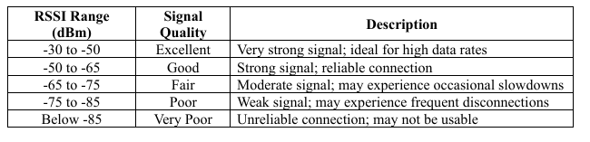

Channel: Wi-Fi networks operate on specific frequency channels. In the 2.4 GHz band, channels are spaced 5 MHz apart, but only channels 1, 6, and 11 are non-overlapping. In the 5 GHz band, there are many more non-overlapping channels available, reducing interference. e) Frequency Band: Wi-Fi operates primarily in two frequency bands:

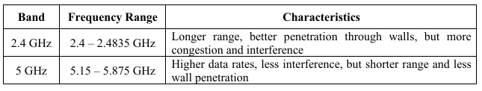

Channel Congestion: When multiple Wi-Fi networks operate on the same or overlapping channels, they compete for the same spectrum, leading to reduced throughput, increased latency, and degraded performance. Channel congestion is a common problem in the 2.4 GHz band.

Working Principle :

Wi-Fi analyzers work by passively listening to beacon frames broadcast by access points. Beacon frames contain information about the network, including the SSID, BSSID, supported data rates, and channel information. The application measures the received signal strength of these frames to calculate RSSI.

Practical Applications

• Network Planning: Site surveys to determine optimal placement of access points.

• Interference Detection: Identifying sources of interference and selecting the least congested channel. • Network Troubleshooting: Diagnosing poor Wi-Fi performance.

• Home Networking: Optimizing router placement and channel selection for better coverage.

Experimental Setup: Since this is a practical hands-on experiment, the setup involves using a smartphone with the Wi Fi Analyzer app in an environment with multiple Wi-Fi networks.

Procedure :

1. Install the WiFi Analyzer (open-source) app by VREM Software Development from the Google Play Store.

2. Open the app and grant the required permissions (location permission is typically required for scanning Wi-Fi networks).

3. Ensure Wi-Fi is enabled on your smartphone.

4. Familiarize yourself with the following views in the app:

Network List View: Shows all detected networks with SSID, RSSI, channel, frequency, and security. Channel Graph View: Shows signal strength of networks across different channels.

Time Graph View: Shows signal strength variation of a selected network over time.

5.Stand at a fixed location (e.g., near your Wi-Fi router).

Record the following information for at least 5 visible Wi-Fi networks in Table 1: SSID, BSSID, RSSI (dBm), Channel, Frequency (GHz), Security

6. Switch to the "Channel Graph" view.

7. Observe which channels are most congested (many networks overlapping on the same channel).

8. Record your observations for both 2.4 GHz and 5 GHz bands.

Observations Screenshots: Paste screenshots here:

Network List View

Channel Graph View

3. Time Graph View (for your own network)

Table 1: Wi-Fi Network Parameters

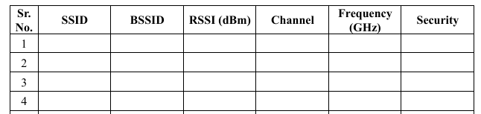

From Table 1, identify the network with the highest RSSI and the network with the lowest RSSI.

Table 2: Channel Utilization Summary

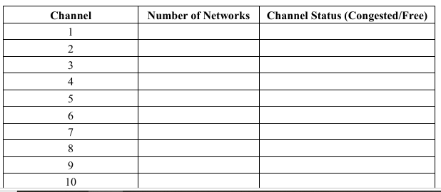

From Table 2, which channel in the 2.4 GHz band is most congested? What are the consequences of channel congestion?

Result and Conclusion

